Servo Motor Knob

Control the position of a RC (hobby) [servo motor](http://en.wikipedia.org/wiki/Servo_motor#RC_servos) with your Arduino and a potentiometer.

This example makes use of the Arduino [servo library](https://www.arduino.cc/en/Reference/Servo).

Hardware Required

* Arduino or Genuino Board
* Servo Motor
* 10k ohm potentiometer
* hook-up wires

Circuit

Servo motors have three wires: power, ground, and signal. The power wire is typically red, and should be connected to the 5V pin on the Arduino or Genuino board. The ground wire is typically black or brown and should be connected to a ground pin on the board. The signal pin is typically yellow or orange and should be connected to pin 9 on the board.

The potentiometer should be wired so that its two outer pins are connected to power (+5V) and ground, and its middle pin is connected to analog input 0 on the board.

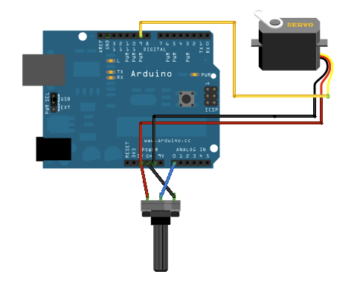

Schematic

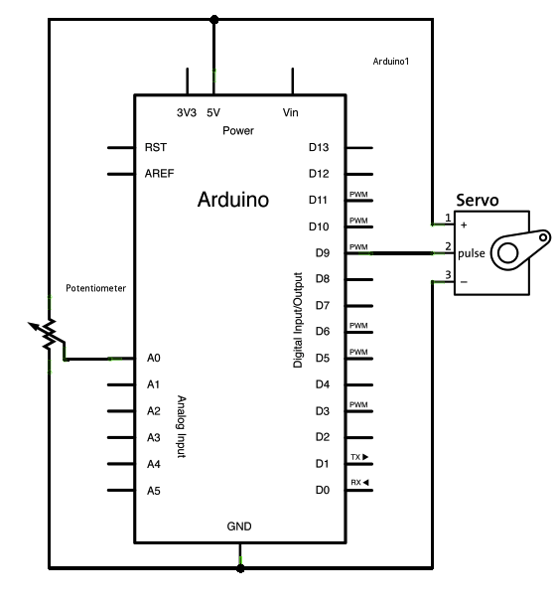

Code

#include <Servo.h>  
  
Servo myservo;  *// create servo object to control a servo*  
  
int potpin = 0;  *// analog pin used to connect the potentiometer*  
int val;    *// variable to read the value from the analog pin*  
  
void **setup**() {  
  myservo.attach(9);  *// attaches the servo on pin 9 to the servo object*  
}  
  
void **loop**() {  
  val = analogRead(potpin);            *// reads the value of the potentiometer (value between 0 and 1023)*  
  val = map(val, 0, 1023, 0, 180);     *// scale it to use it with the servo (value between 0 and 180)*  
  myservo.write(val);                  *// sets the servo position according to the scaled value*  
  delay(15);                           *// waits for the servo to get there*  
}